How to put web app code on Azure Web app :

Refer : <https://docs.microsoft.com/en-us/azure/app-service/app-service-deploy-ftp>

1. Create an empty web on azure portal by going to below option and select appropriate details :

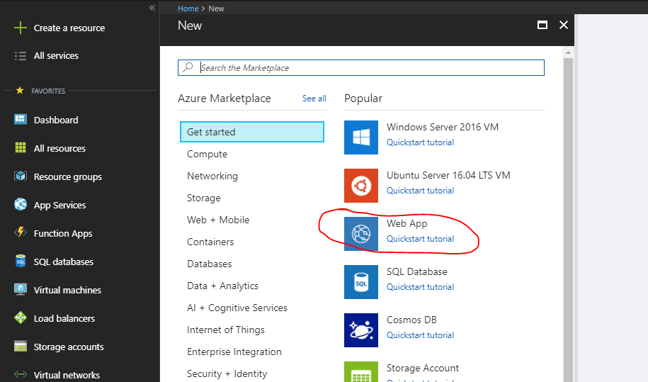

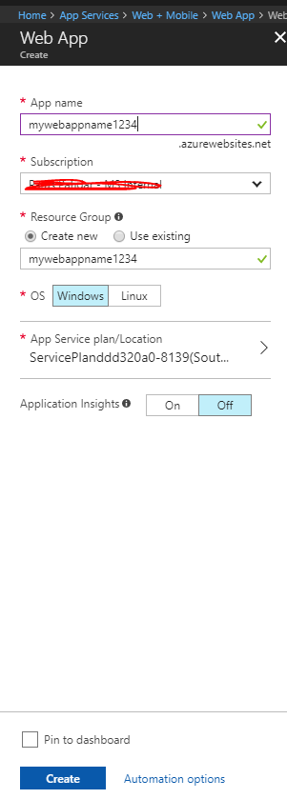

1. Once the web app is created, go to Overview options & downloads the publishing profile and save it in your PC somewhere:

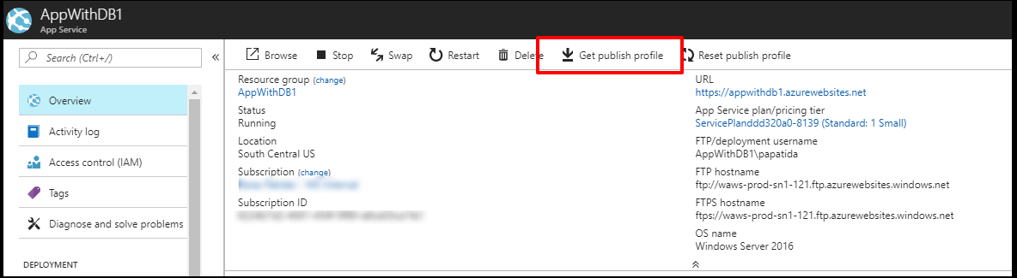

1. Open visual studio with solution opened.
2. Try build your solution and see if build successes.
3. Now go to publish option of visual studio

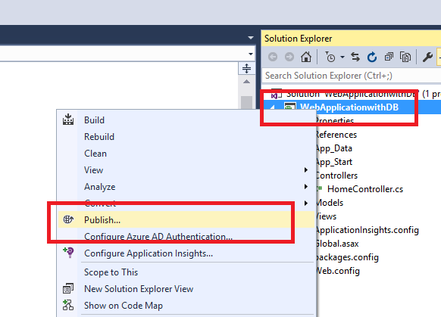

1. Click on Import and browse to the publishing profile which was downloaded in step 2

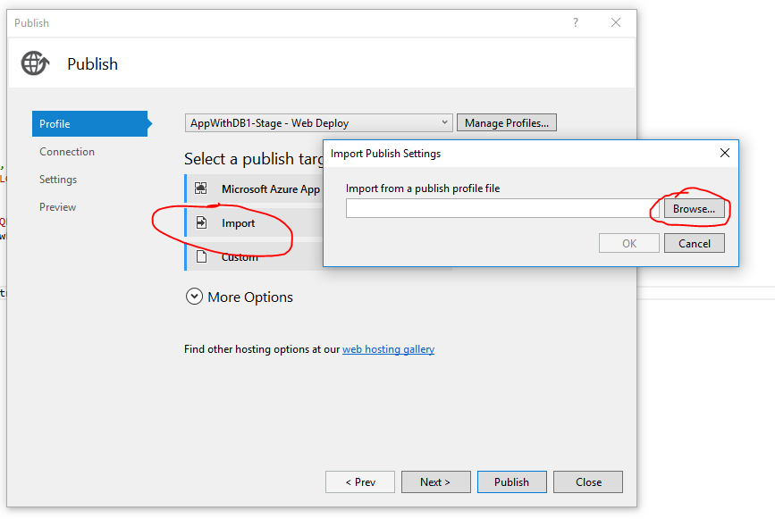

1. After import it will take you ro “Connection” option , just verify the web app name is correct , & click Next

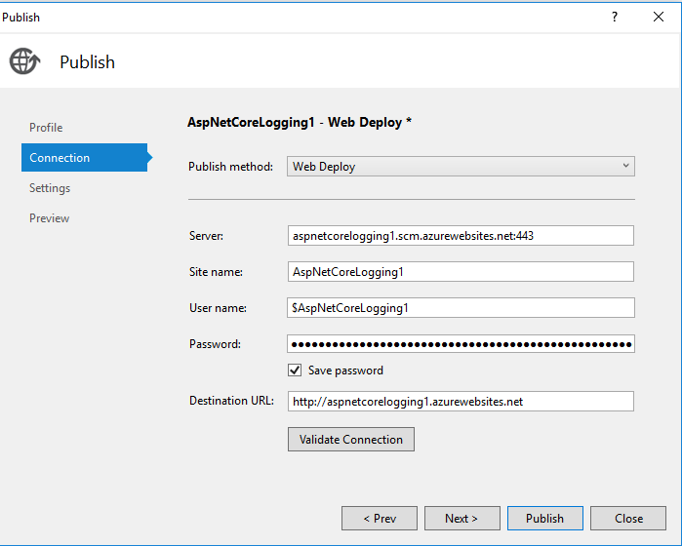

1. In “Setting” option select the mode (debug /release )

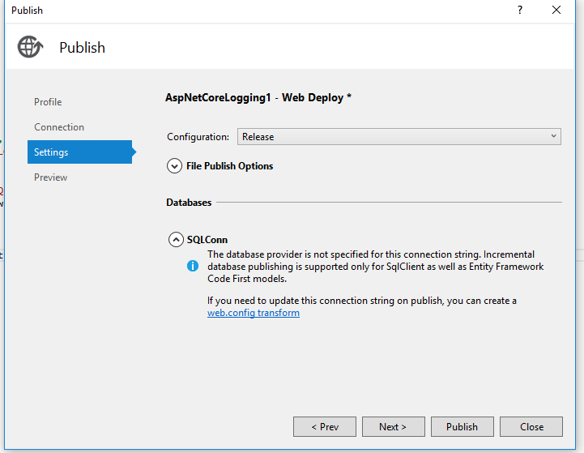

1. Click on “Next” and “Publish” to publish the web app.

